**ALL STAR ADMIN**

Link- https://allstaradmin-9cd26.web.app/#/login

1. **Referral management-**

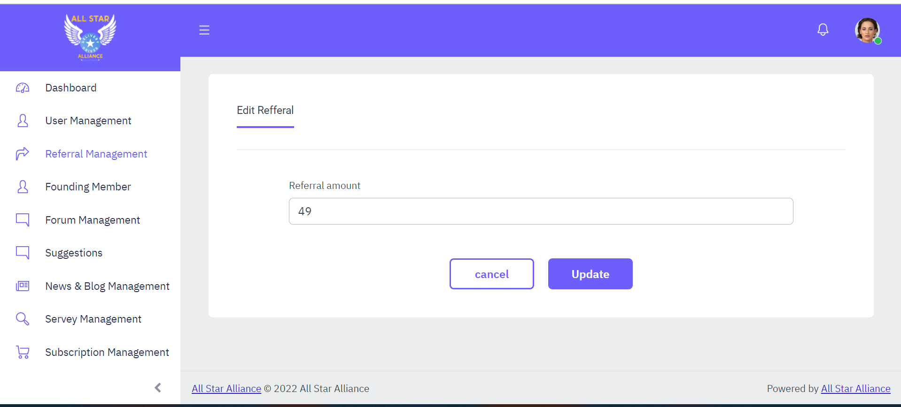

Admin can edit referral amount of users.

1. Subscription management-

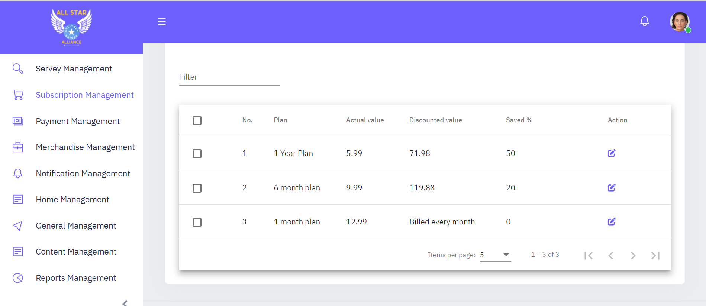

Admin can manage subscriptions from admin panel, same will be reflected to user side.

1. Edit subscription plan

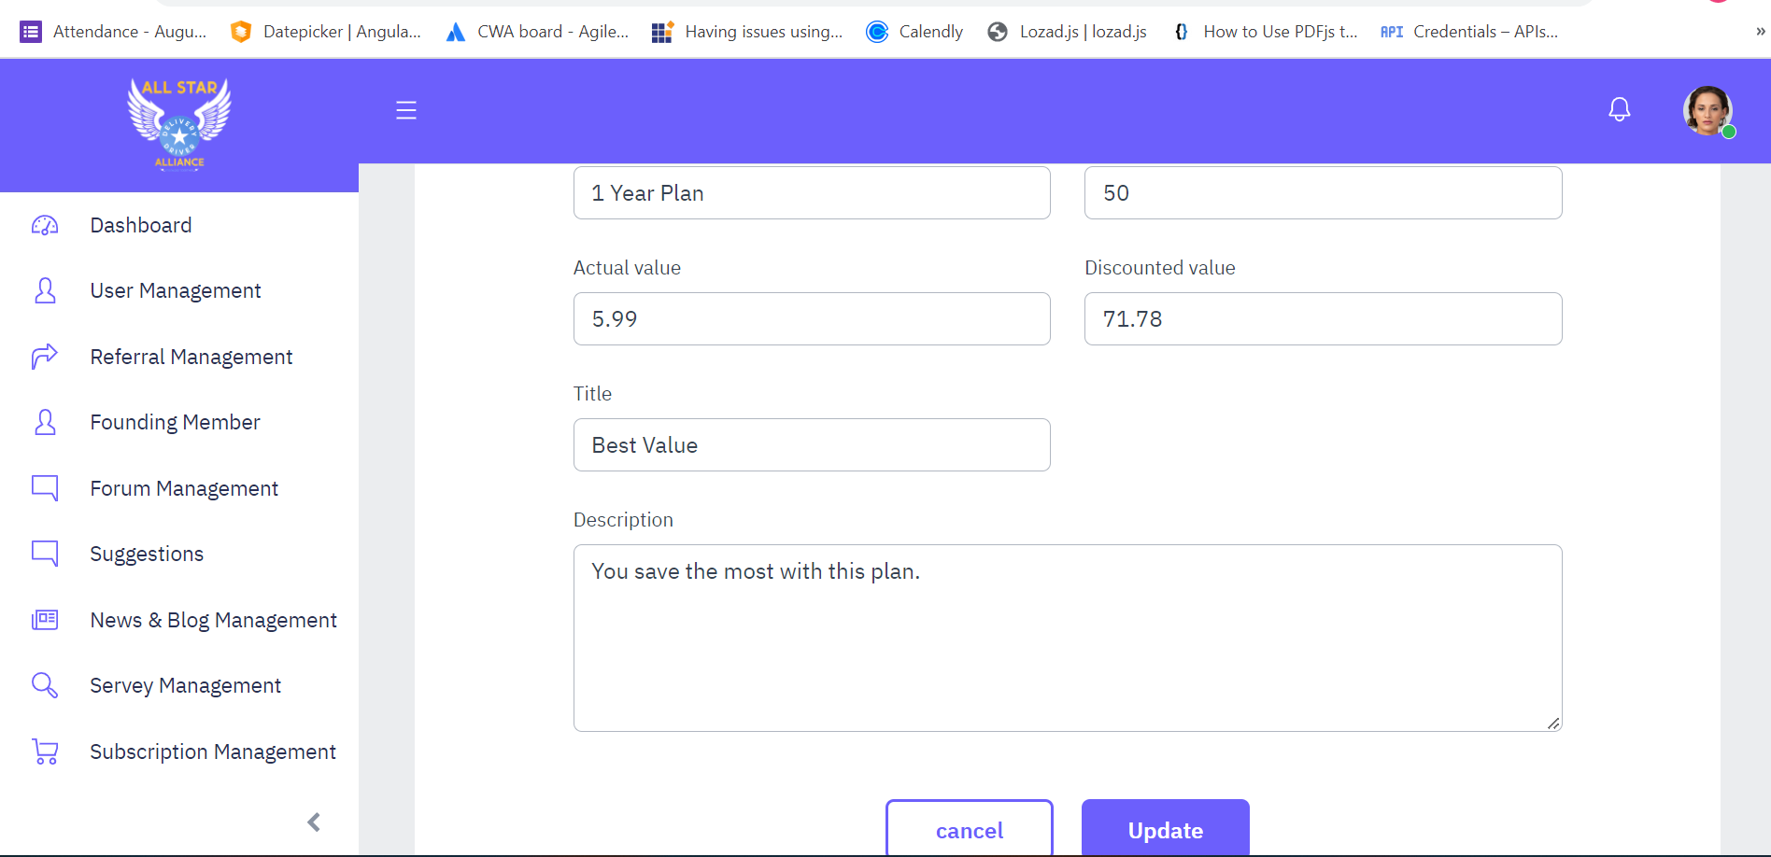

Admin can edit subscription plan entries.

1. Home management-
2. Our main feature-

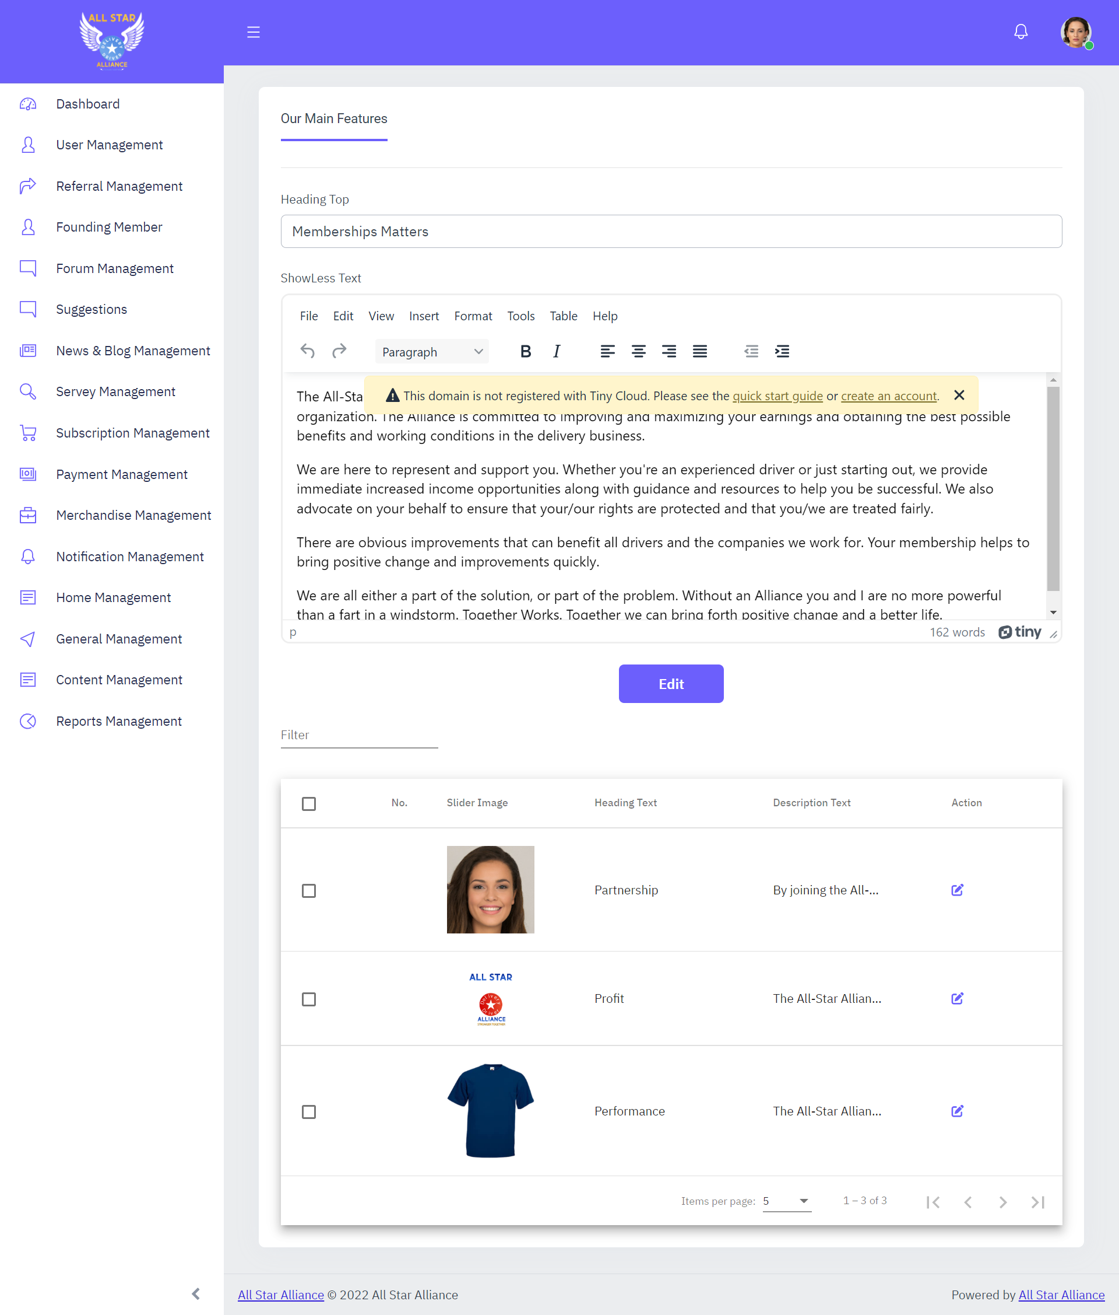

Our main features are now admin manageable.

1. Edit features-

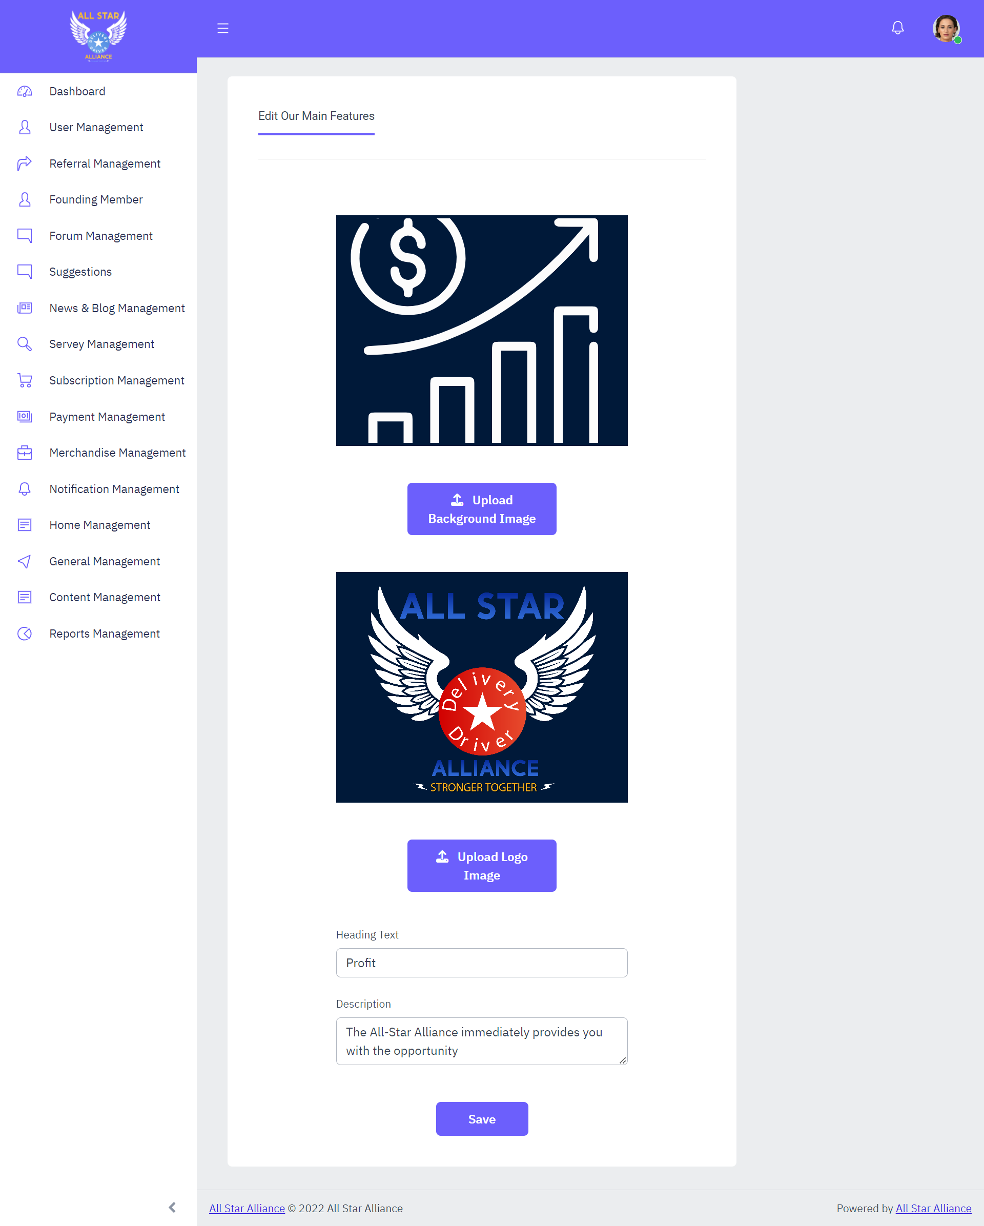

User can edit the data.